**Team 30: Restaurant Management System**

*Sprint 7: Presentation Plan*

*Plan Prepared By: Thong Nguyen*

*Date: March 06, 2020*

**Part I: Mobile Version**

|  |  |
| --- | --- |
| **Responsible Member** | **Team Role** |
| Thanh Quan | Mobile Application Developer |
| Tu Nguyen | Mobile Application Developer |

1. **Thanh Quan - Manager dashboard and its features**

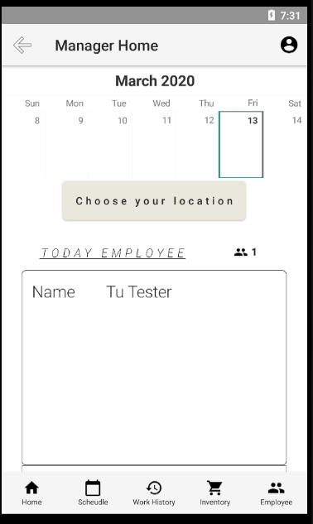

Figure 1: Manager Home Page

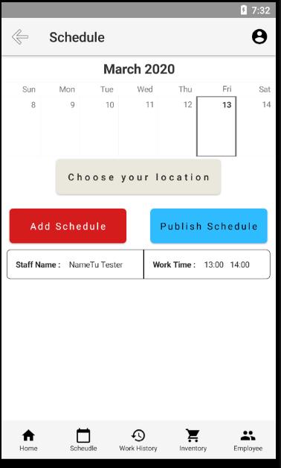

Figure 2: Manager Schedule

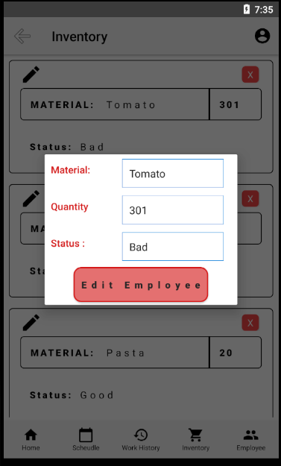

Figure 3: Inventory Edit

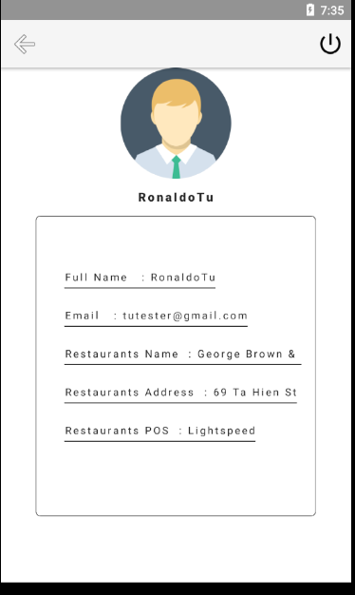

Figure 4: User Profile

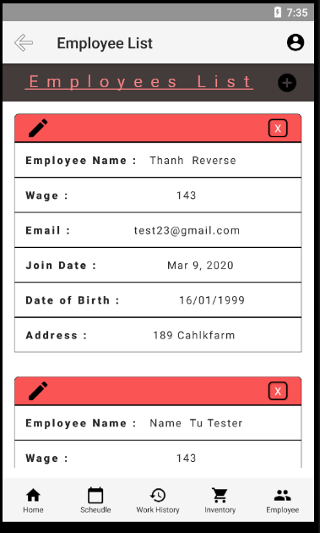

Figure 5: Employee List

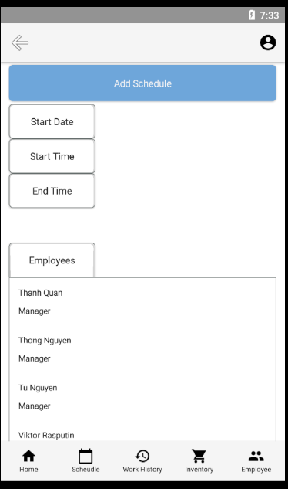

Figure 6: Manager: Add Schedule function

1. **Tu Nguyen - Mobile Authentication and Employee Dashboard**

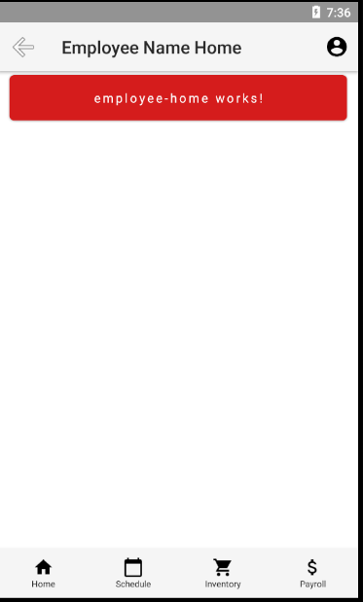

Figure 7: Employee Hone (Under construction)

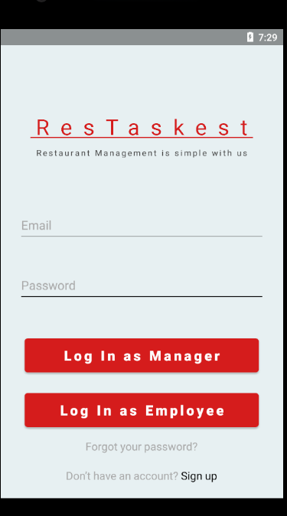

Figure 8: Login

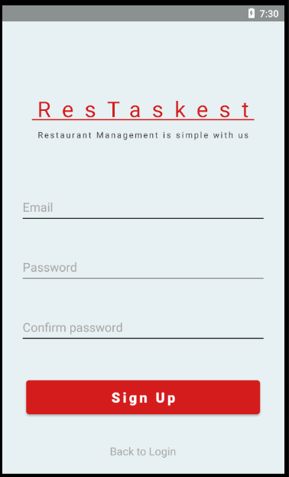

Figure 9: Sign Up

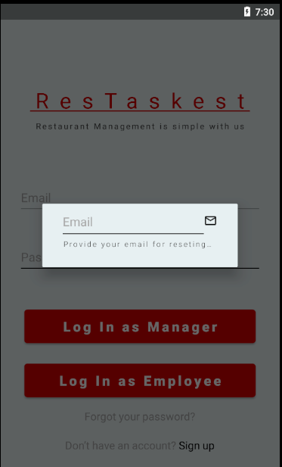

Figure 10: Password

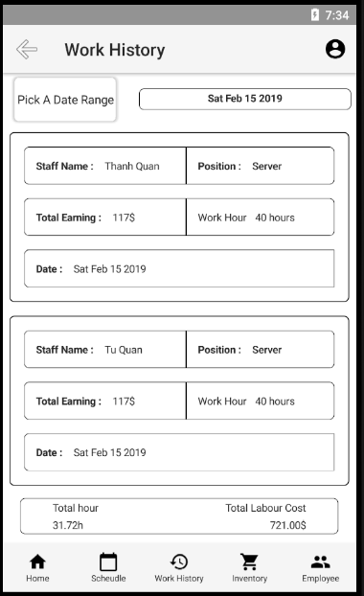

Figure 11: Work History

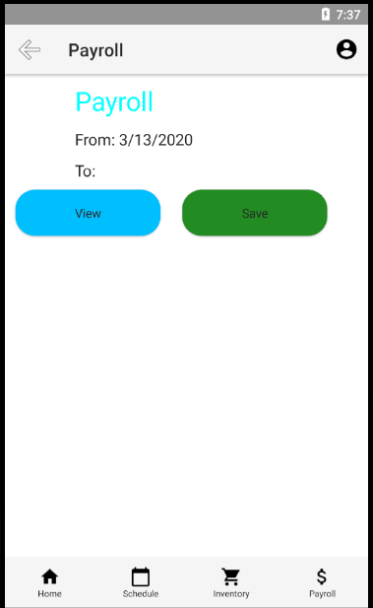

Figure 12: Employee PayRoll

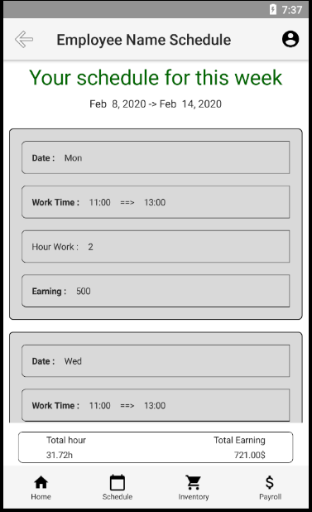

Figure 13: Employee Schedule

**Part II: Web Version**

|  |  |
| --- | --- |
| **Responsible Member** | **Team Role** |
| Thong Nguyen | Team Leader |
| Quang Pham | Full Stack Developer |

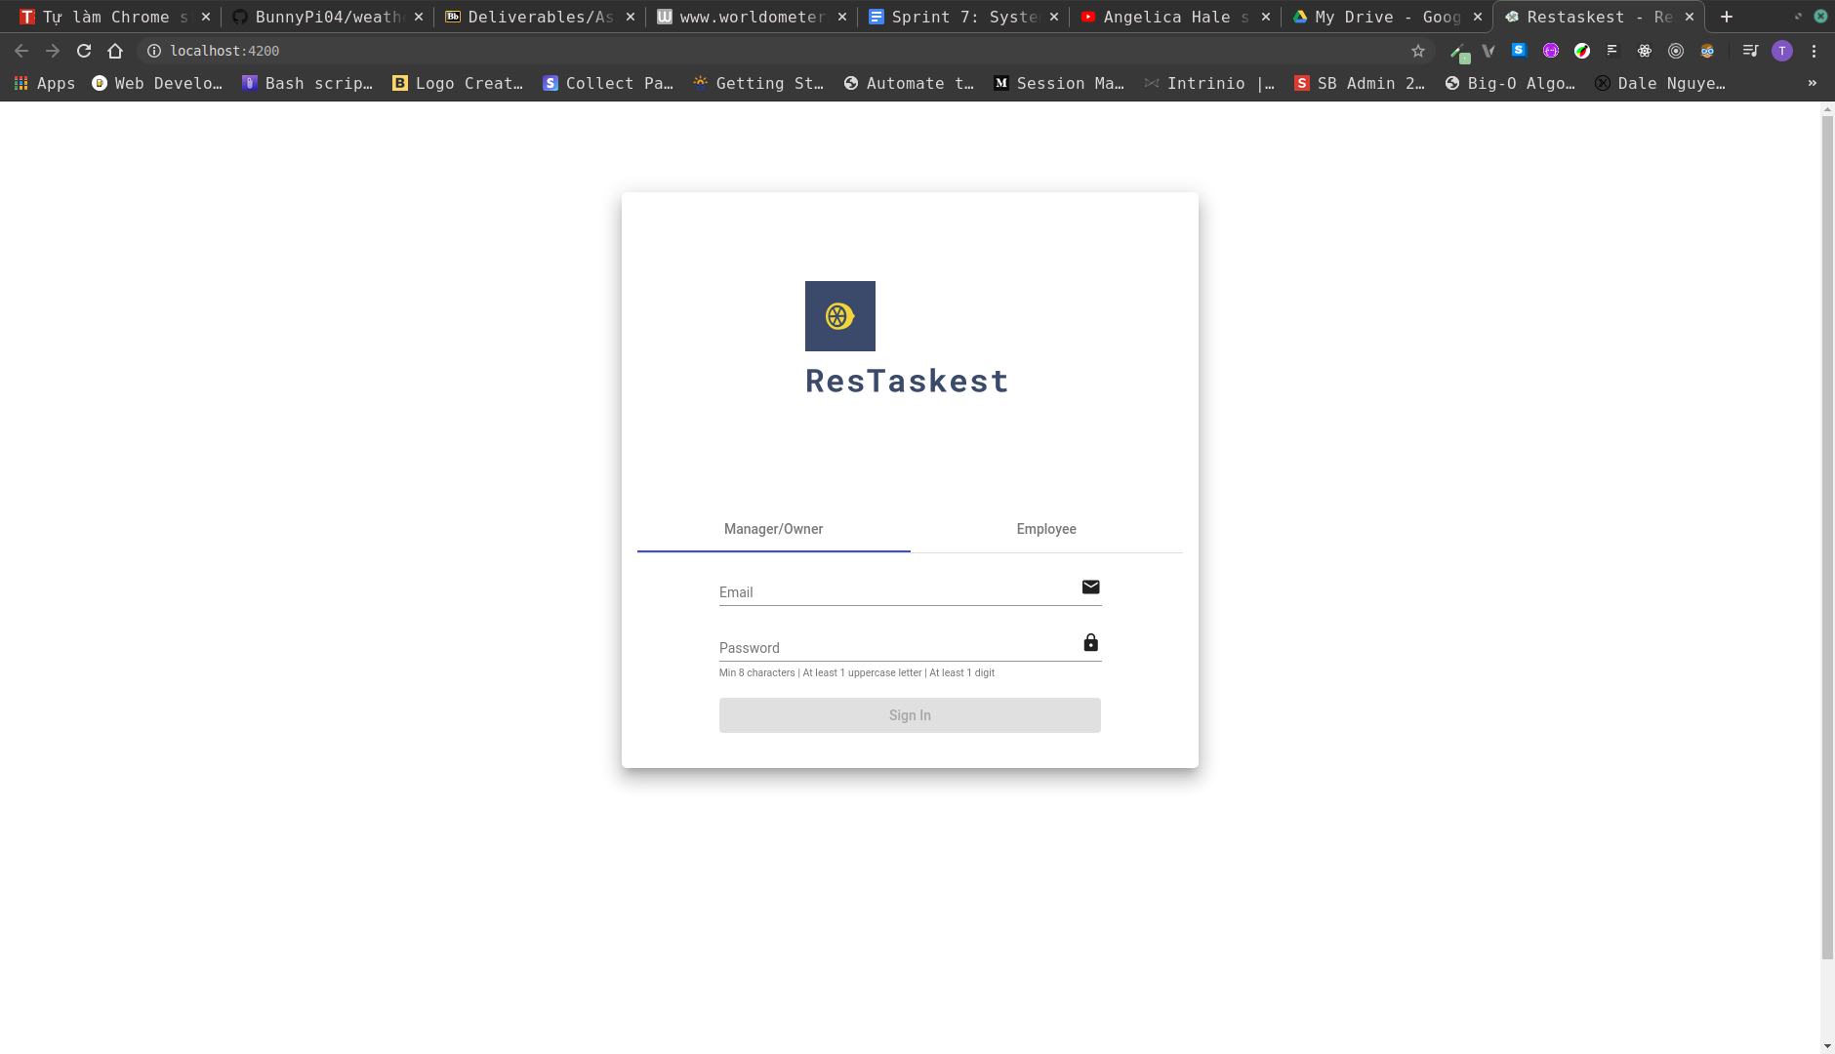

Figure 14: Web App Login

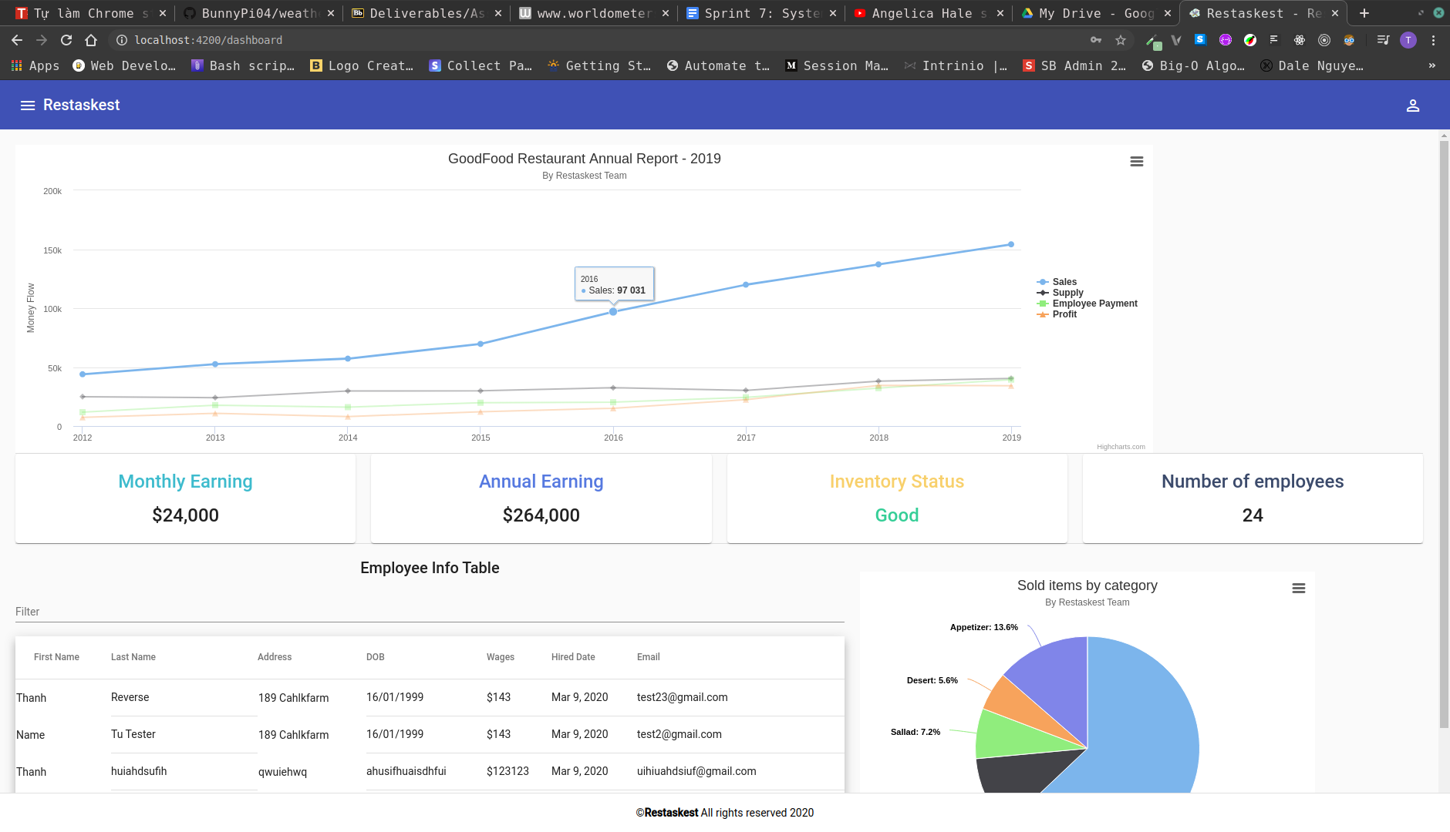

Figure 15: Manager Dashboard with charts and summary

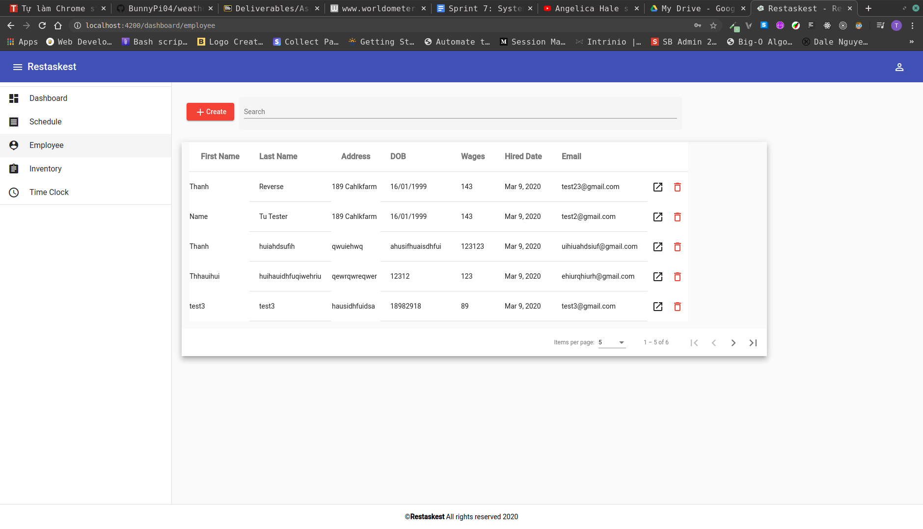

Figure 16: Employee Window